Stride WMS
Billing & QuickBooks Guide

Version 2.0.0 | March 2026
For Billing Administrators

1. Overview
Stride uses a two-system approach to billing:
- Google Sheets tracks all charges automatically (receiving, tasks, repairs, storage)
- QuickBooks Desktop creates and sends the actual invoices
The workflow: Sheets captures charges → you review and select → export to QuickBooks IIF → import into QB → QB creates invoices.
This eliminates maintaining two invoice systems and lets QuickBooks handle payment tracking, aging reports, and tax reporting.
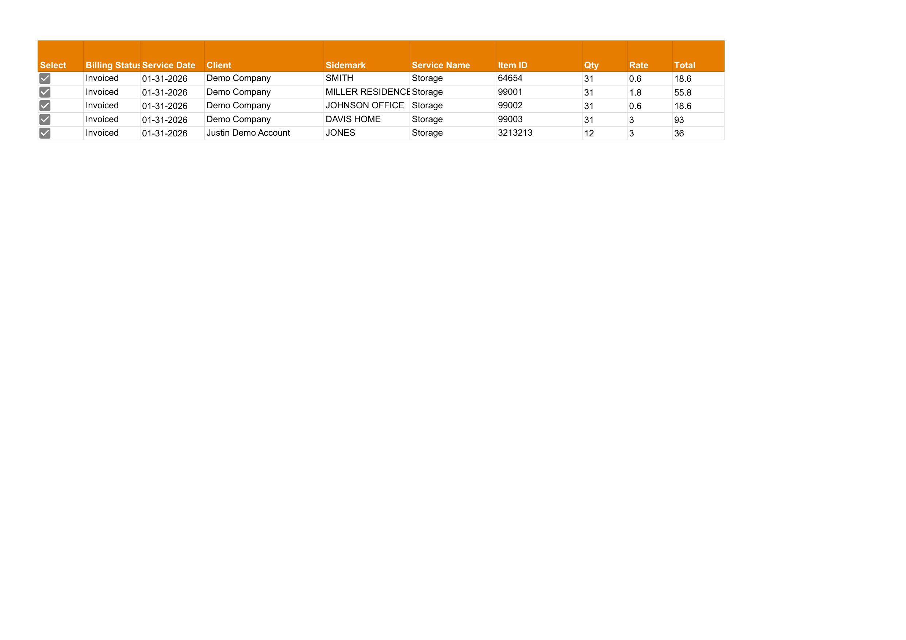
2. How Charges Are Created
Charges are created automatically throughout the warehouse workflow. You do not need to manually create billing rows.
2.1 Receiving Charges (RCVG)
- Created when: A Dock Intake shipment is completed
- Condition: Client setting "Enable Receiving Billing" must be TRUE
- Rate: Based on item Class from the Master Price List
- One row per item received
2.2 Task Charges (INSP, Custom)
- Created when: A task Result (Pass/Fail) is entered
- Condition: Task must be billable (based on Price List settings for pass/fail billing)
- Rate: Based on service code and item Class
- One row per completed task
2.3 Repair Charges (REPAIR)
- Created when: A repair is completed (Repair Result entered)
- Rate: Based on the Quote Amount that was approved
- One row per completed repair
2.4 Storage Charges (STOR)
- Created when: You run "Generate Storage Charges" from the billing menu
- Rate: Daily rate × cubic volume × number of billable days
- Calculation: (Class base rate from Price List) × (cubic volume from Class_Cache) × (billable days)
- Free storage days are subtracted from the billing period
- Released items are only billed up to (but not including) the release date
3. Weekly Billing Workflow
This is the primary billing process for receiving, tasks, and repairs. Run weekly.
Step 1: Open the Consolidated Billing Spreadsheet
Open the Consolidated Billing spreadsheet in Google Sheets.
Step 2: Generate the Unbilled Report
- Click Stride Billing menu at the top
- Click "Generate Unbilled Report"
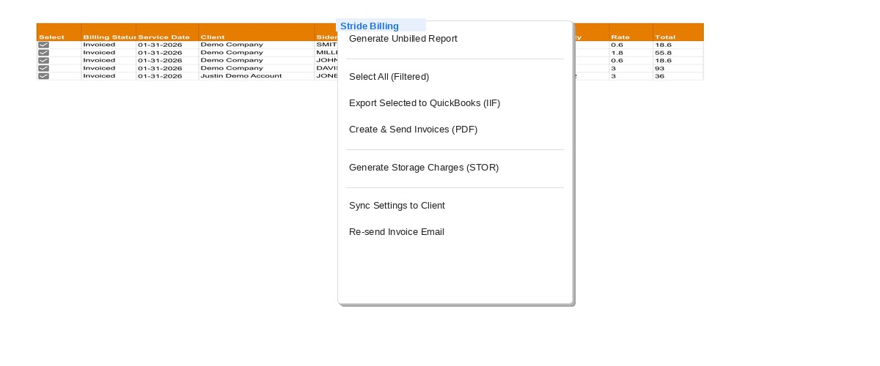
Step 3: Enter the End Date
- Enter the end date in MM/DD/YY format (e.g., 03/15/26)
- Click OK
- The system scans all active clients and pulls in unbilled charges
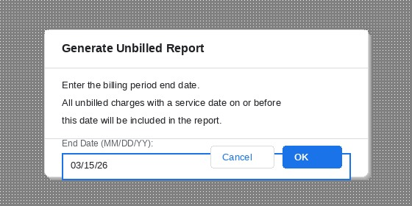
Step 4: Review the Unbilled Report
- Click the Unbilled_Report tab
- Review the charges listed
- Use Google Sheets filters to sort by Client, Svc Code, Date, etc.
The report shows:
Column | Description
Select | Checkbox to select rows for export
Billing Status | Unbilled, Invoiced, or Void
Client | Client name
Sidemark | Project/job reference
Service Date | When the charge occurred
Service Name | Description of the service
Qty | Quantity
Rate | Unit rate
Total | Total charge amount
Svc Code | Service code (RCVG, INSP, STOR, REPAIR)
Item ID | Which inventory item

Step 5: Select Rows to Bill
- Check the Select boxes (column A) on the rows you want to include
- Or use Stride Billing → "Select All (Filtered)" to check all visible rows
- Use filters first if you want to bill only specific clients or services
Tip: Filter by Client first, then Select All, to bill one client at a time.

Step 6: Export to QuickBooks
- Click Stride Billing → "Export Selected to QuickBooks (IIF)"
The system will:
- Group selected rows by client (and by sidemark if enabled)
- Assign invoice numbers via the Master system
- Generate an IIF file
- Write records to Consolidated_Ledger
- Mark rows as Invoiced
- Update client Billing_Ledger rows
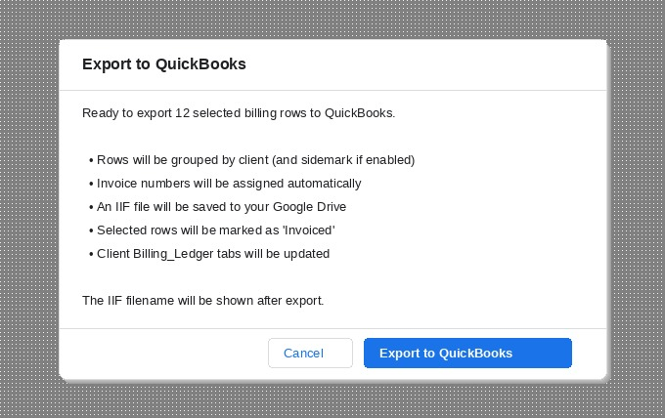
Step 7: Download the IIF File
- The IIF file is saved to your Google Drive
- Go to Google Drive and search for the filename shown in the confirmation
- Download the .iif file to your computer
Important: Make sure the file keeps the .iif extension. Some browsers may change it to .txt.
Step 8: Import into QuickBooks Desktop
- Open QuickBooks Desktop
- Go to File → Utilities → Import → IIF Files
- Select the downloaded .iif file
- Click Open
- QuickBooks will create the invoices
[Screenshot - see QuickBooks Desktop: QuickBooks IIF import menu]
Step 9: Review in QuickBooks
- Go to Customers → Customer Center
- Find the client(s)
- Review the newly created invoices
- Send invoices to clients via QuickBooks (email or print)
4. Monthly Storage Billing
Storage charges are generated separately, typically once per month.
Step 1: Generate Storage Charges
- Click Stride Billing → "Generate Storage Charges (STOR)"
- Enter the Start Date (first day of billing period)
- Enter the End Date (last day of billing period)
- Example: For March billing, enter 03/01/26 to 03/31/26
Step 2: What Happens
The system:
- Scans each active client's Inventory for items with a Receive Date
- Calculates billable days (subtracting free storage days)
- Skips items that were released before the billing period
- Does NOT bill the release date (item leaves at start of that day)
- Creates STOR rows in each client's Billing_Ledger with status "Unbilled"
- Uses an idempotency key to prevent double-billing the same period
Step 3: Pull into Unbilled Report
- Run "Generate Unbilled Report" (same as weekly workflow)
- STOR charges will appear alongside any other unbilled charges
- You can filter by Svc Code = "STOR" to see only storage
Step 4: Export to QuickBooks
Follow Steps 5–9 from the Weekly Billing Workflow above.

5. Sidemark Billing (Interior Designers)
What Is Sidemark Billing?
Interior design clients often have multiple projects in the warehouse at the same time. Each project is identified by a "sidemark" (project name). These clients want a separate invoice for each project, not one combined invoice.
Setting Up Sidemark Billing
- Open the Consolidated Billing spreadsheet
- Go to the Clients tab
- Find the client row
- Set "Separate By Sidemark" to TRUE
- Click on the client row
- Click Stride Billing → Sync Settings to Client
How It Works
When exporting to QuickBooks:
- Clients with Separate By Sidemark = TRUE: One invoice per sidemark
- Clients with Separate By Sidemark = FALSE: One invoice per client (all sidemarks combined)
Example: Client "ABC Design" has sidemarks "Smith Residence" and "Jones Office"
- With TRUE: Two invoices (one for Smith, one for Jones)
- With FALSE: One invoice combining all charges
6. QB_Service_Mapping Setup
The QB_Service_Mapping tab tells the system how to map Stride service codes to QuickBooks accounts.
Columns
Column | Required? | Description
Svc Code | Yes | Stride service code (RCVG, INSP, STOR, REPAIR, etc.)
Svc Name | Yes | Human-readable service name
QB Income Account | Yes | QuickBooks income account name (must match exactly)
Default Payment Terms | No | Fallback payment terms (e.g., "Net 30")
QB Item Name | Recommended | QuickBooks item name for line items (must match QB exactly)
Example Setup
Svc Code | Svc Name | QB Income Account | Default Payment Terms | QB Item Name
RCVG | Receiving | Warehouse Services | Net 30 | Receiving
INSP | Inspection | Warehouse Services | Net 30 | Inspection
STOR | Storage | Storage Revenue | Net 30 | Storage
REPAIR | Repair Services | Repair Revenue | Net 30 | Repair
ASSY | Assembly | Warehouse Services | Net 30 | Assembly
DLVR | Delivery | Delivery Revenue | Net 30 | Delivery
Important: The QB Income Account and QB Item Name must match exactly what's in your QuickBooks Desktop. If they don't match, the IIF import will fail.
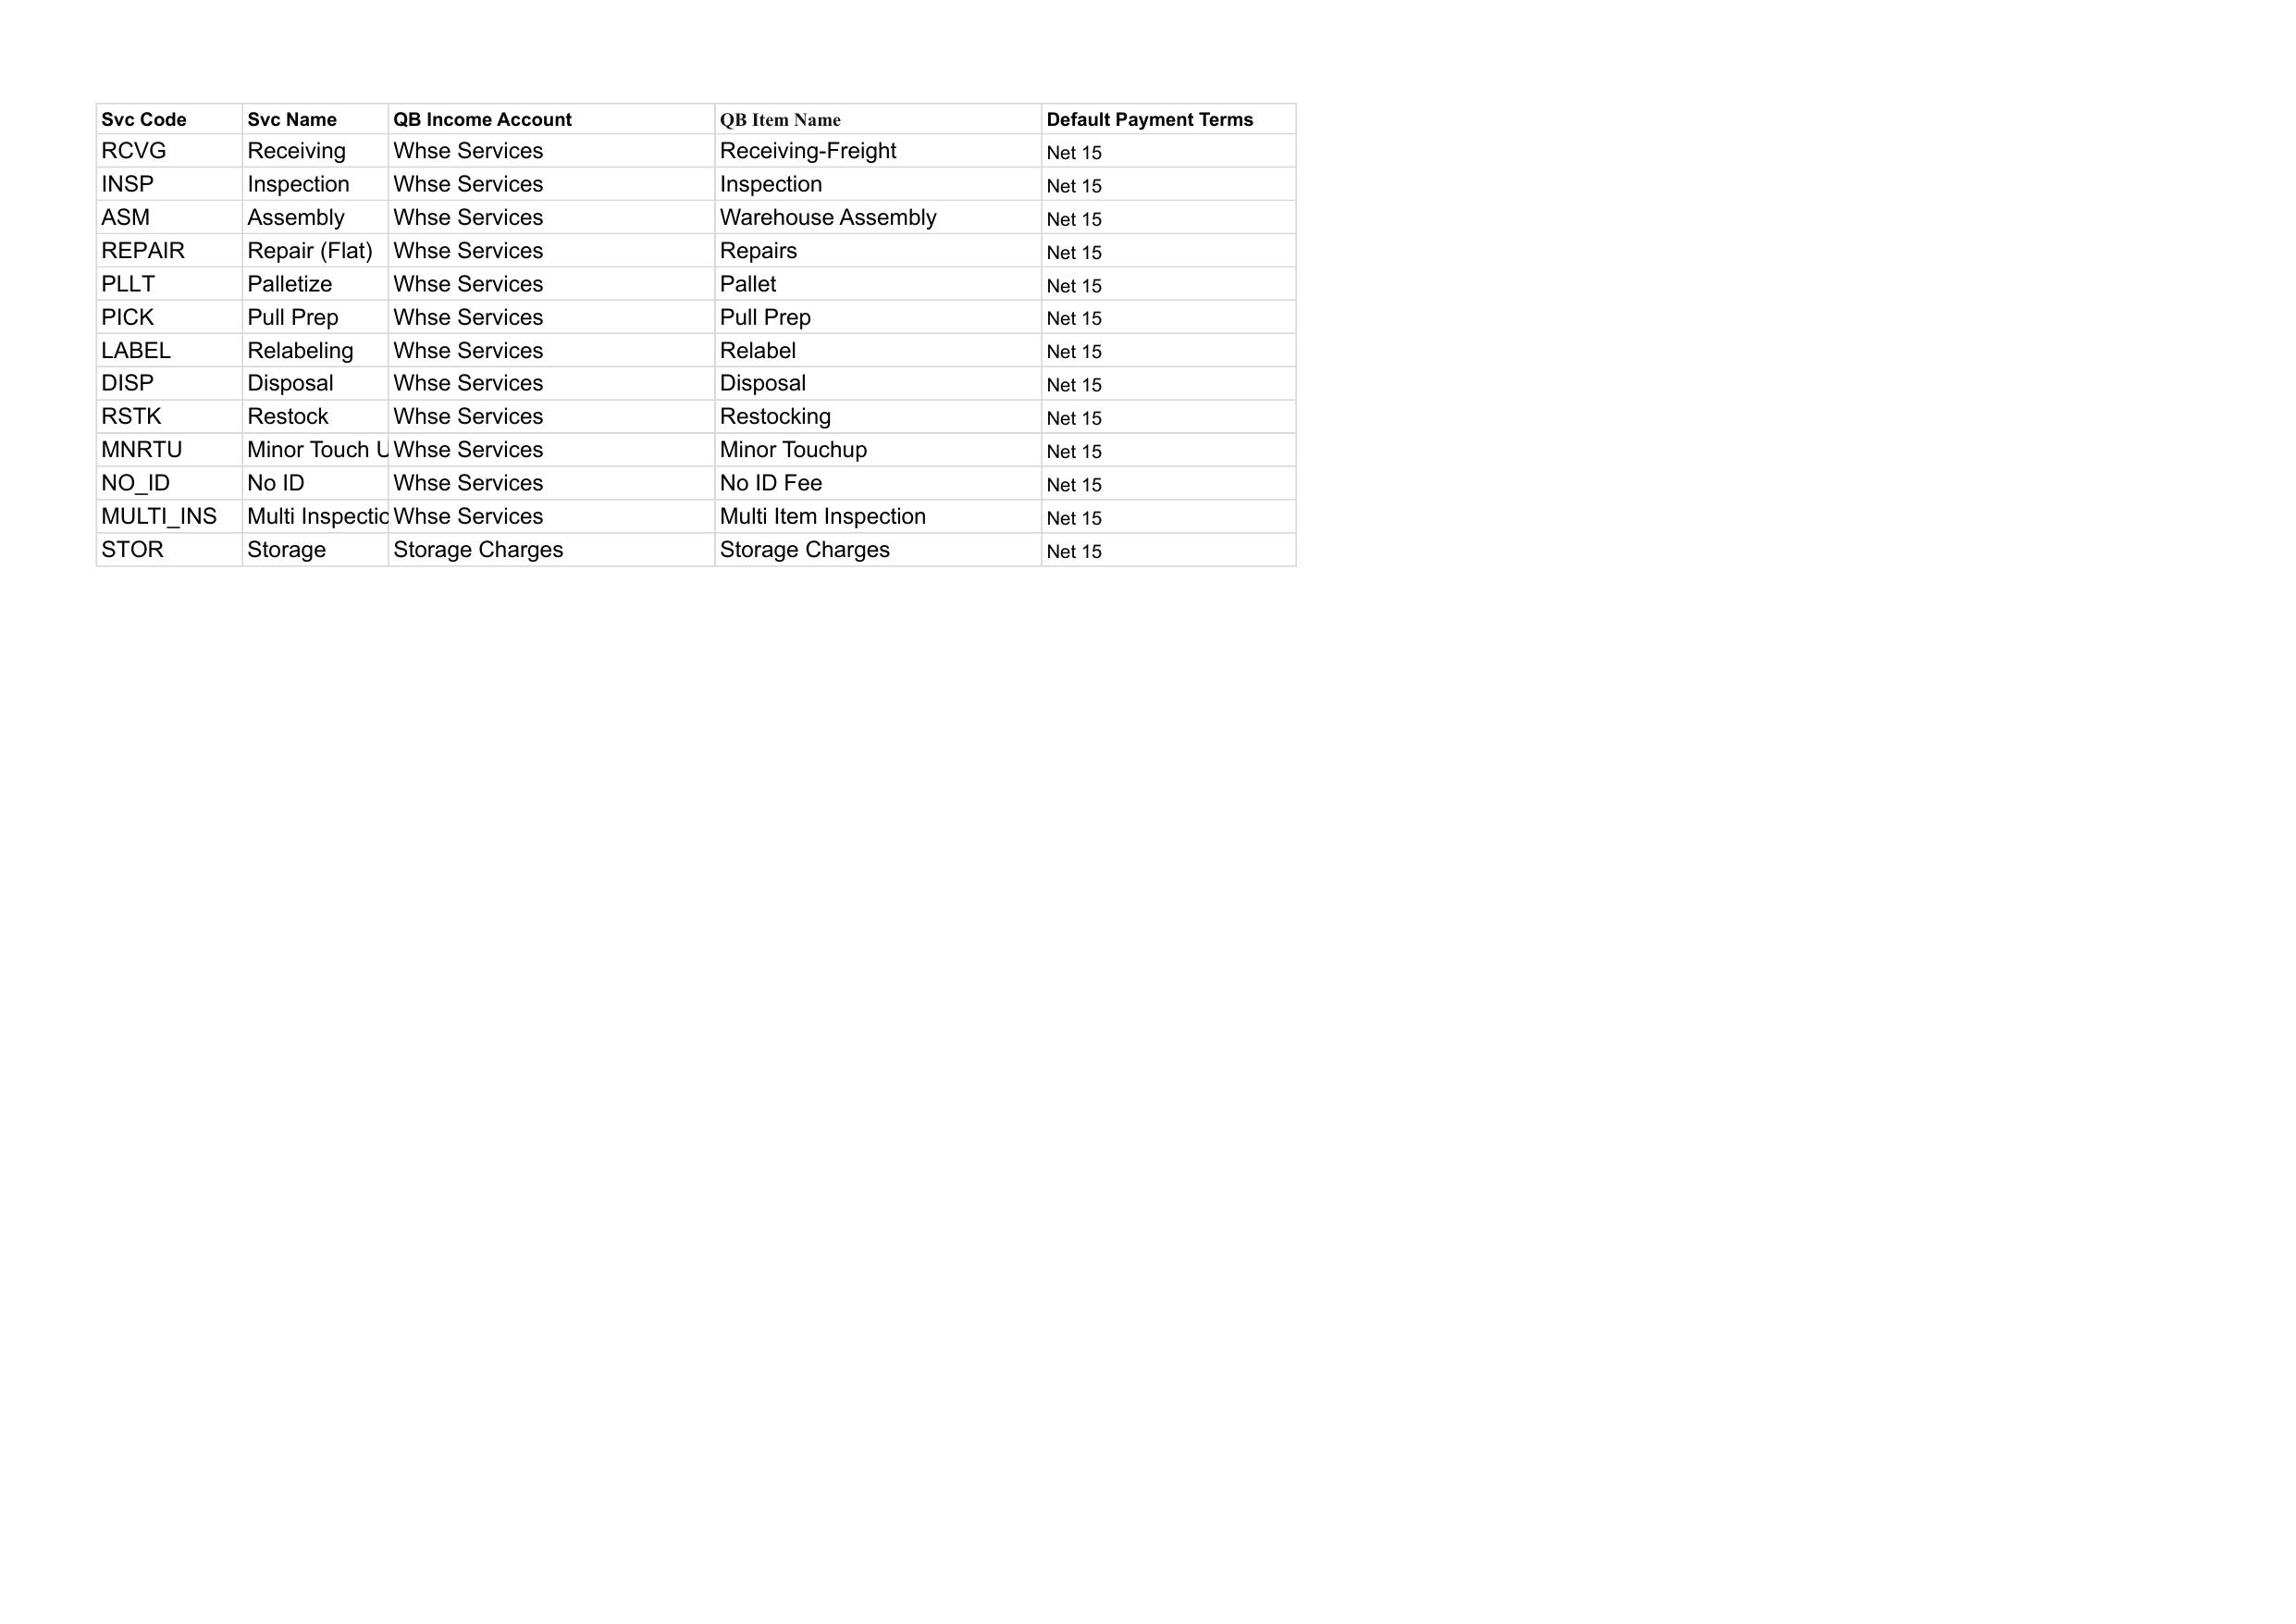
7. Consolidated Ledger
What It Tracks
The Consolidated_Ledger tab is the master record of all invoiced charges across all clients. Every time you export to QuickBooks, the system writes records here.
Key Columns
Column | Description
Status | Invoiced or Void
Invoice # | Invoice number assigned by the system
Client | Client name
Date | Service date
Svc Code | Service code
Total | Charge amount
Email Status | Sent, Not Sent, or Failed
Invoice URL | Link to the invoice document (if PDF was generated)
Two-Way Sync
If you edit the Status or Invoice # in the Consolidated_Ledger, the change is automatically pushed back to the client's Billing_Ledger. This keeps both ledgers in sync.
8. PDF Invoices (Backup Option)
For situations where you need a PDF invoice (QuickBooks is down, client requests one, etc.):
- Go to the Unbilled_Report tab
- Check the Select boxes on rows to invoice
- Click Stride Billing → "Create & Send Invoices (PDF)"
The system will:
- Group rows by client (and sidemark if enabled)
- Generate invoice numbers
- Create a Google Doc from the invoice template
- Convert to PDF
- Save PDF to client's Invoices folder and Master Accounting folder
- Email the PDF to the client
Note: This is a backup option. The primary workflow should use the QB export.
9. Re-sending Invoice Emails
If an invoice email failed or needs to be re-sent:
- Go to the Consolidated_Ledger tab
- Click on any cell in the row of the invoice you want to re-send
- Click Stride Billing → "Re-send Invoice Email"
- The system will find the PDF and re-email it to the client
10. Troubleshooting
Problem | Cause | Fix
"No active clients found" | Clients tab Active column unchecked | Check the Active checkbox for each client
"Missing MASTER_RPC_URL" | Client Settings tab missing server info | Run Sync Settings to Client from Billing
"QB Income Account missing" | QB_Service_Mapping incomplete | Add the service code to QB_Service_Mapping
Storage charges = $0 | Missing volume data or rates | Check Class_Cache has cubic volumes and Price_List has STOR rates
IIF import fails in QB | Account/item names don't match | Verify QB Income Account and QB Item Name match QB exactly
"No Ledger Entry IDs provided" | Billing_Ledger missing IDs | Run Generate Storage Charges first, then Unbilled Report
Double charges appearing | Ran storage generation twice for same period | System prevents this with idempotency keys — check Task IDs
"Another run is in progress" | Previous run didn't finish cleanly | Wait 30 seconds and try again
Billing Log
The Billing_Log tab records all billing operations with timestamps, success/failure status, and suggested fixes. Check this tab when troubleshooting billing issues.
